Visitor Information
The Institute for Advanced Manufacturing and Engineering,
Beresford Avenue,
Coventry,
CV6 5LZ

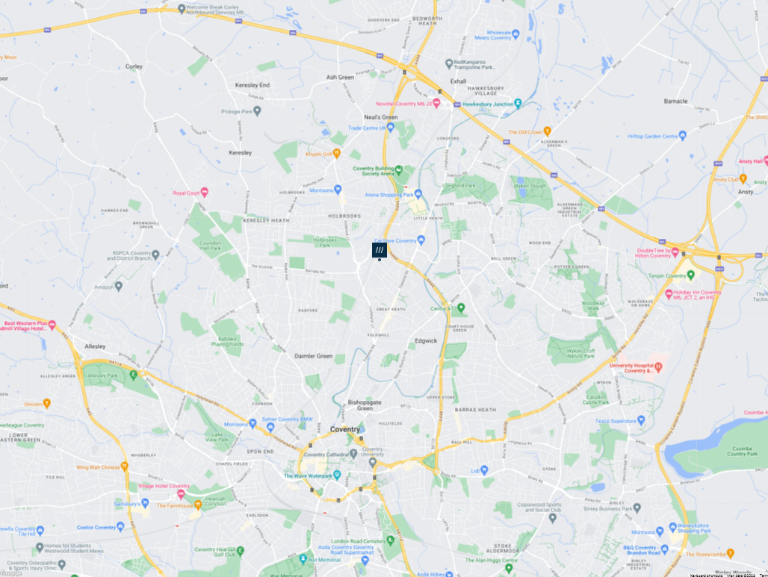

SATNAV: Use postcode CV6 5JA
What3Words: https://w3w.co/roses.prime.galaxy

Location of the site entrance on Beresford Avenue

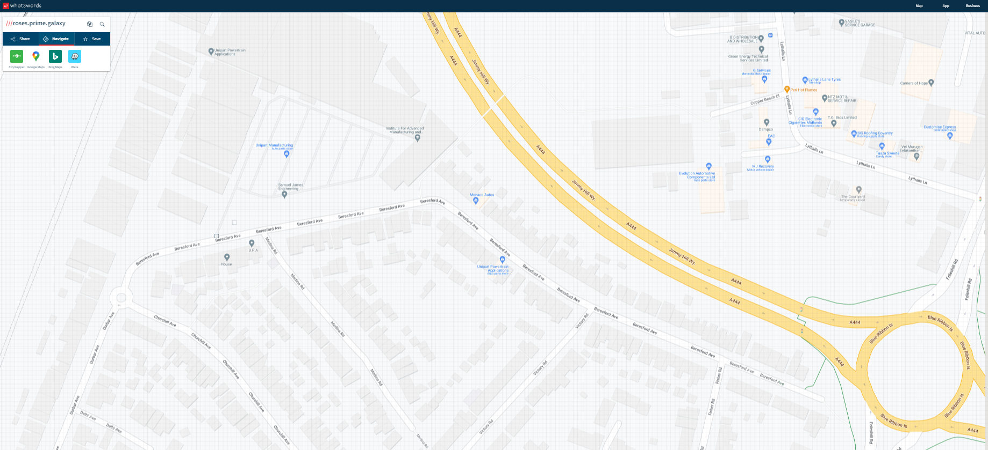
A
B

The site entrance is shown as ‘A’ on the map above.
Upon arrival, please proceed around the edge of the car park (as per the dotted lines on the map), to the far end of the building. The AME entrance is marked ‘B’ on the map above.
You will be asked to sign in and provide your vehicle registration number when you arrive at AME Reception.

Pedestrians are requested to use the pedestrian walkways at all times.
Drivers are requested to observe site speed limits whilst on site and reverse park into parking bays.



If you require further information prior to your visit, please contact cgfm.admin@coventry.ac.uk

